**Setting up Prometheus and Grafana in Kubernetes cluster :**

**Prometheus**

Prometheus is an open-source monitoring and alerting tool. It is widely used in projects to monitor microservices. It collects, filters, and aggregates the metrics from the microservices and then produces them in a human-readable format. In Prometheus, your whole project is centralized, and you can control the application from a single server and view the metrics on an HTTP endpoint on your web browser.

**Grafana**

Grafana is a monitoring and observability tool, we can create a dashboard and visualize our logs and metrics. When connected to the supported data source, it produces charts, alerts, and graphs.

Lets deploy the promethus in the AKS cluster .

1. Login to the AKS cluster using the cloud shell provided by the Azure terminal

az account set --subscription 2d460c9d-8e92-4000-a62f-af9105b62514

az aks get-credentials --resource-group kubernetes --name zakriakubernetes --overwrite-existing

2. install Promethues:

Lets install the Prometheus for the data extraction from the Kubernetes cluster   
  
Run the below commands to install the Prometheus:

helm repo add prometheus-community <https://prometheus-community.github.io/helm-charts>  
  
helm install prometheus prometheus-community/prometheus -n monitoring

kubectl port-forward service/prometheus-server 9030:80 -n monitoring

we need to run the below command to get the public ip for the promethues

kubectl get svc -n monitoring prometheus-server  
  
kubectl patch svc -n monitoring prometheus-server -p '{"spec": {"type": "LoadBalancer"}}'

kubectl get svc -n monitoring prometheus-server

Now open the chrome and hit the <http://externalip>

3. Now lets install the Grafana .

helm repo add grafana https://grafana.github.io/helm-charts  
helm install grafana grafana/grafana -n monitoring  
  
for the below command, here we get the password for the Grafana login:

kubectl get secret --namespace monitoring grafana -o jsonpath="{.data.admin-password}" | base64 --decode ; echo   
  
kubectl port-forward service/grafana 9040:80 -n monitoring

we need to run the below command to get the public ip for the grafana

kubectl get svc -n monitoring grafana  
kubectl patch svc -n monitoring grafana -p '{"spec": {"type": "LoadBalancer"}}'

Lets open the Grafana <http://external_ip>

Now we need to add the connection to data stores , click Promethues

Click on the Add new data source

Now provide the name and url http://external_ip:80

Click on the Dashboards > new > import:

Type 315 >load , To load the Grafana dashboard

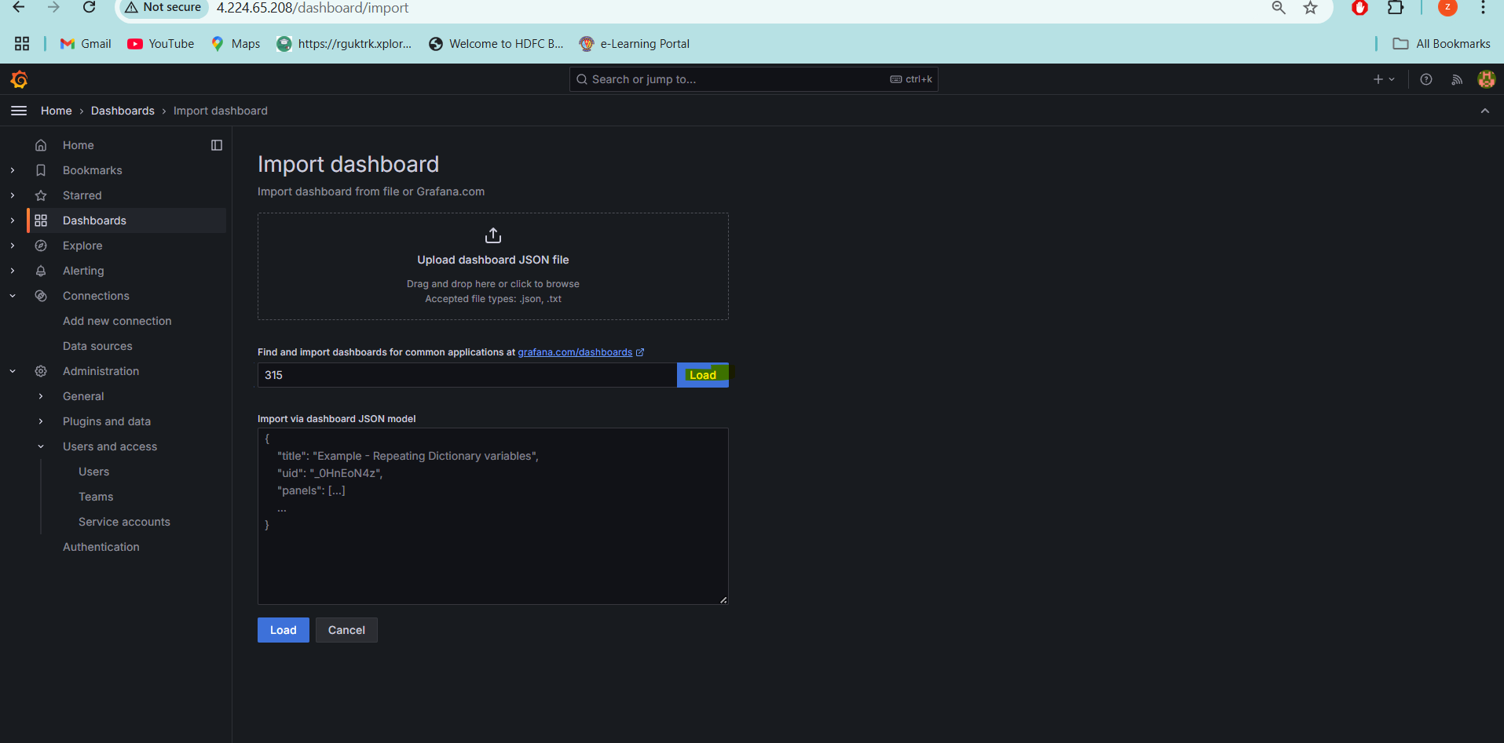

Select the Prometheusdatasource > import :

Perfect , we can see the working :  
  
Now we need to reset the password 1  
Administration > users and access > edit option

